

National Textile University
Department of Computer Science

Subject:
Mobile Application Development

Submitted to:
Sir Rehan

Submitted by:
Asbah Asif

Reg number:
23-NTU-CS-1141

Lab no.:
01

Semester: 6th
Task 1:
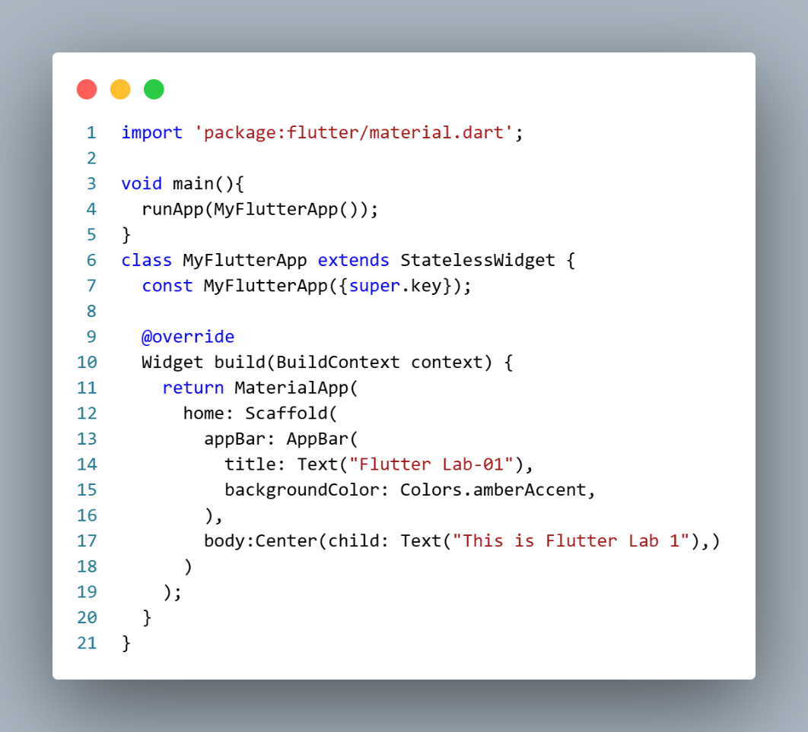

Output:
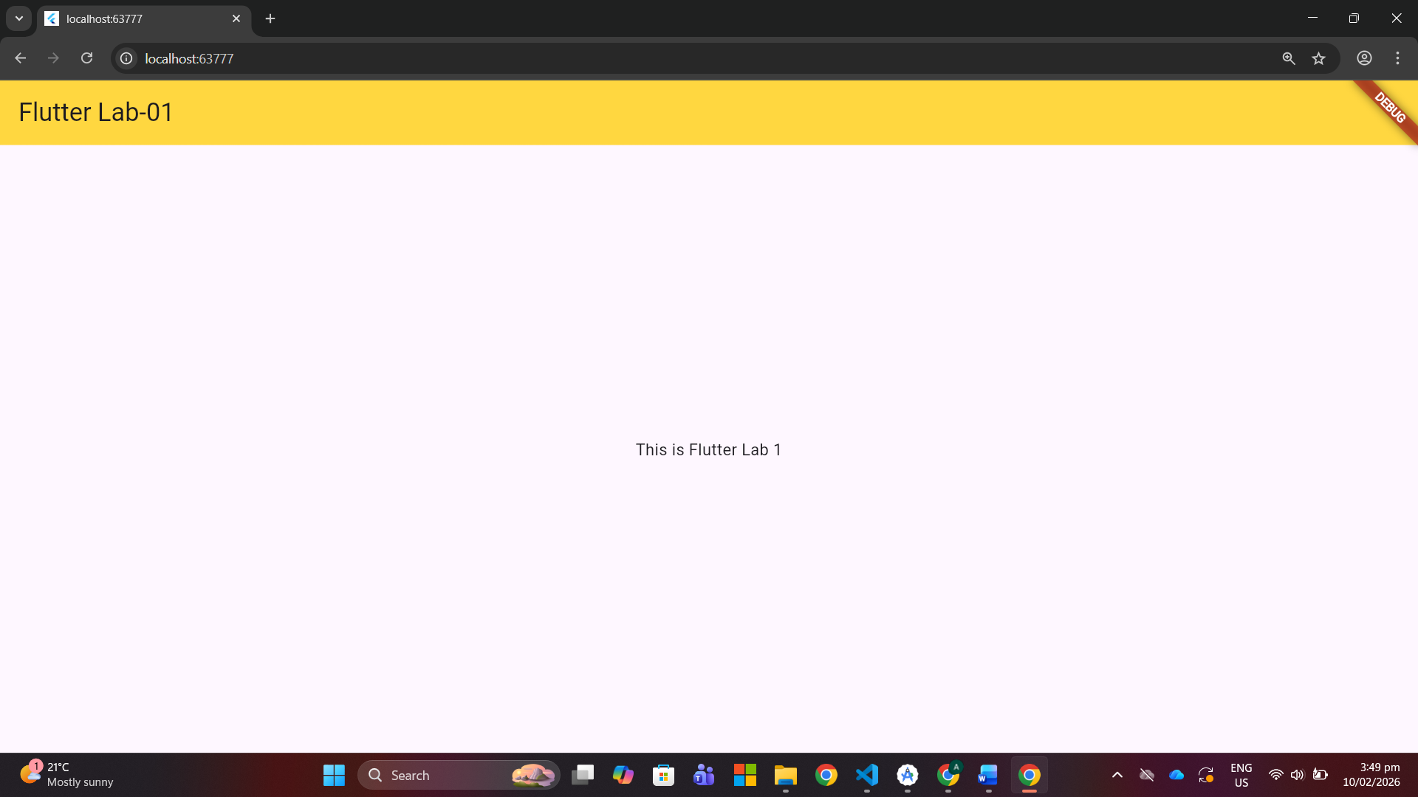
- Design the UI Layout:
  - Inside the `Scaffold`, create a `Column` widget.
  - Add a `Row` widget as the first child of the `Column`.
- Use Size box for spaces.
- Change the color of the Appbar.

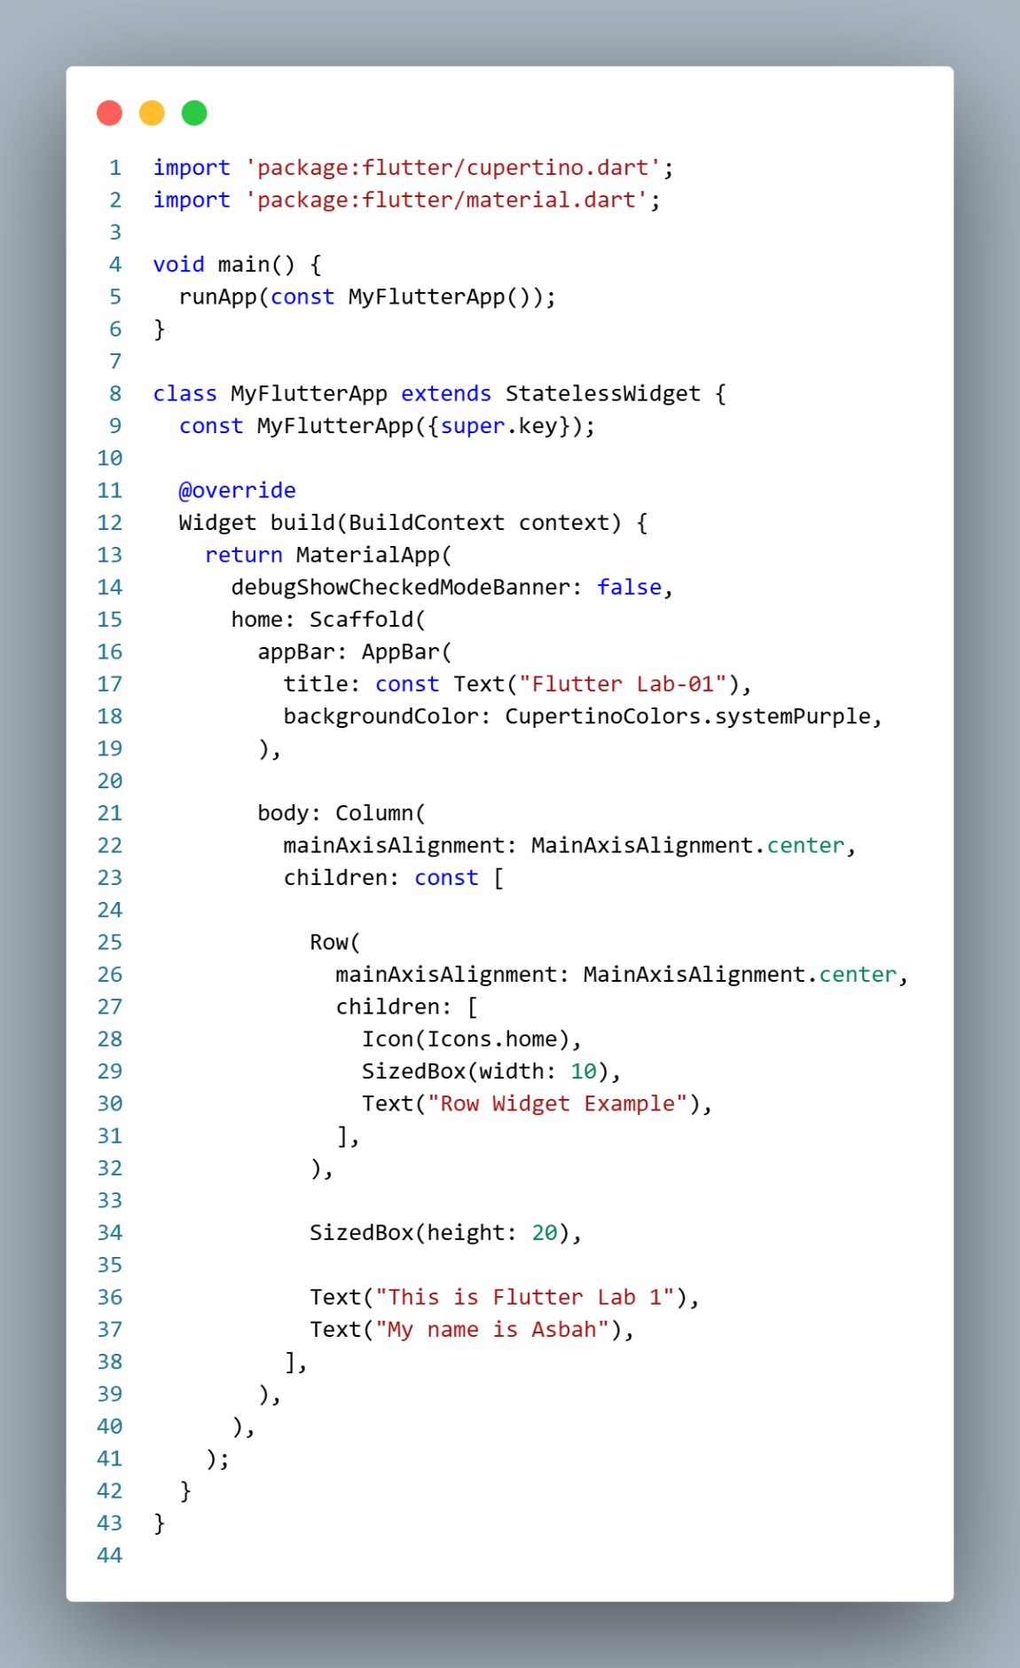

Output:

